|  |
| --- |
| Photo displaying partial image of two pie charts on a canvas-textured page |
| PO3_DGW |
|  |

# Status Table

|  |  |
| --- | --- |
| PO3_DGW_CYRS | |
| *Version* | V0.1 |
| *Status* | Draft |
| *Author* | Bassem Ezzat |
| *Last updated date* | 27/2/2020 |

# Table of history

|  |  |  |  |
| --- | --- | --- | --- |
| *Version* | *Author* | *Date* | *Changes* |
| 0.0 | Bassem Ezzat | January 27, 2020 | Creation of GDD document |

# References

|  |  |  |  |
| --- | --- | --- | --- |
| Ref. Number | Doc. Name | Version | Status |
| 1 | PO3_DGW_SRS | 0.6 | Proposed |

Contents

Status Table 2

Table of history 2

References 3

1-Project Description 5

1.1 Software Features 5

2-Context Diagram 6

2.1Navigation between modes 6

2.2-Display Time Mode. 7

2.3-Alarm Mode 8

8

2.3.1 case of Buzzer 8

2.4-Stopwatch Mode 9

3-API’s Component 10

4-Layered Architecture 15

# 1-Project Description

This section introduces the software requirements specification (SRS) for the Digital Watch.

## 1.1 Software Features

The major feature of the digital watch as listed below.

* Display time with 12 AM/PM format.
* Adjust time.
* Alarm to set according to user input.
* Stopwatch (Start, Stop).
* Three buttons to control the system:
  + MODE
  + FUNC1
  + FUNC2

# 

# 2-Context Diagram

## 2.1Navigation between modes

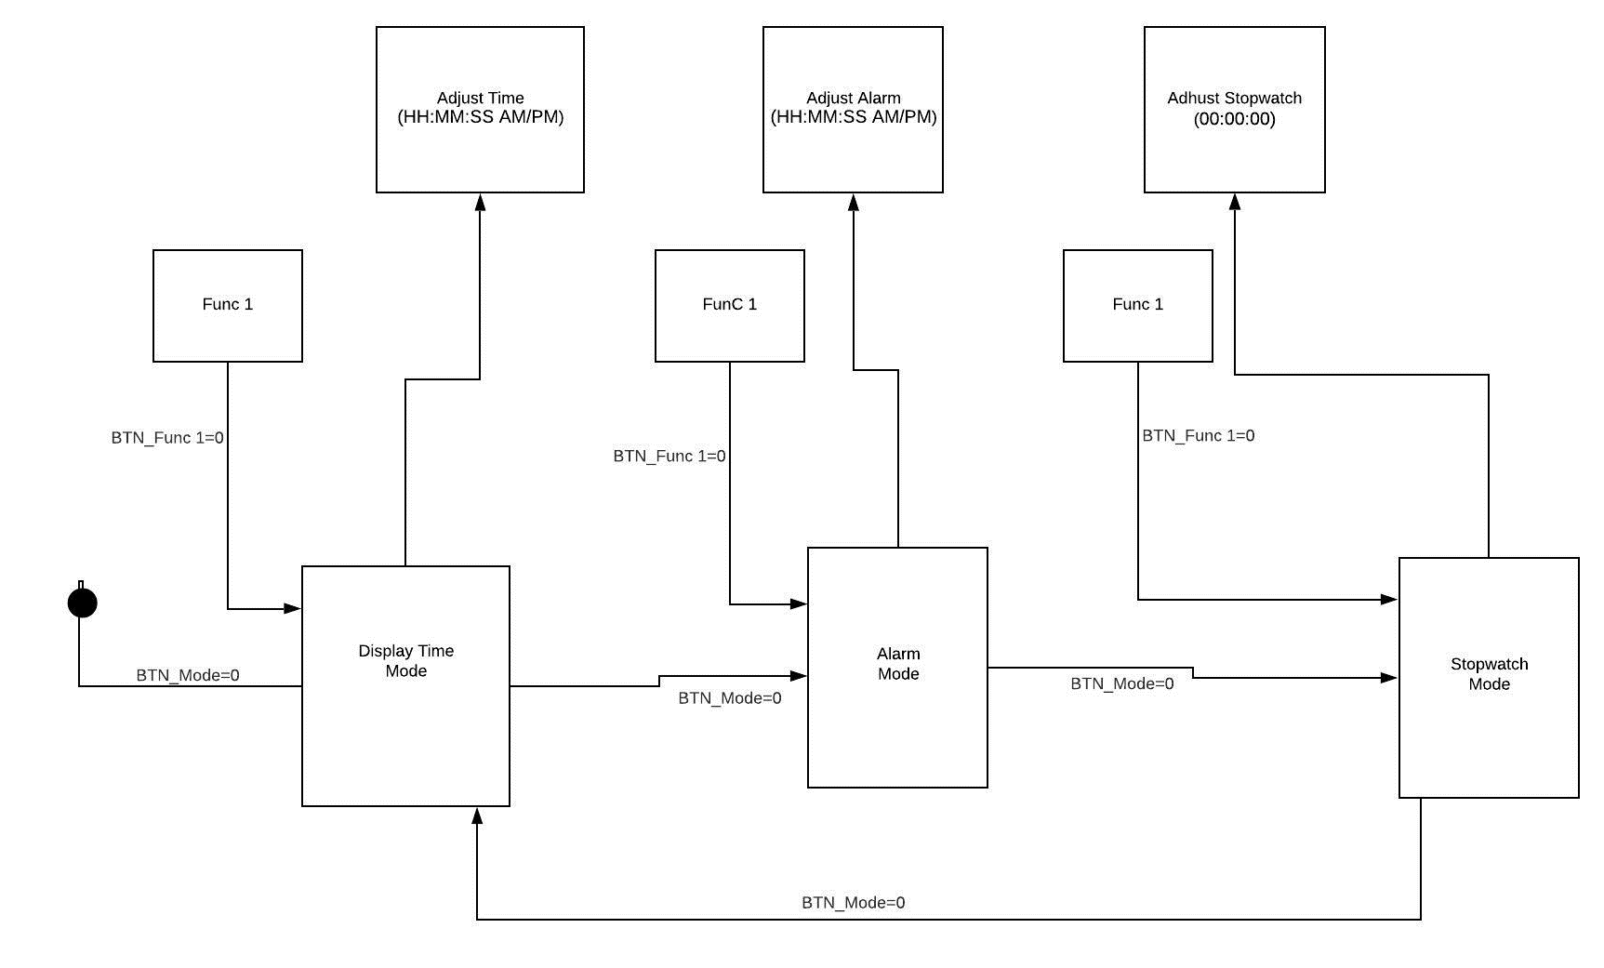

Figure .Navigation between mode

## 2.2-Display Time Mode.

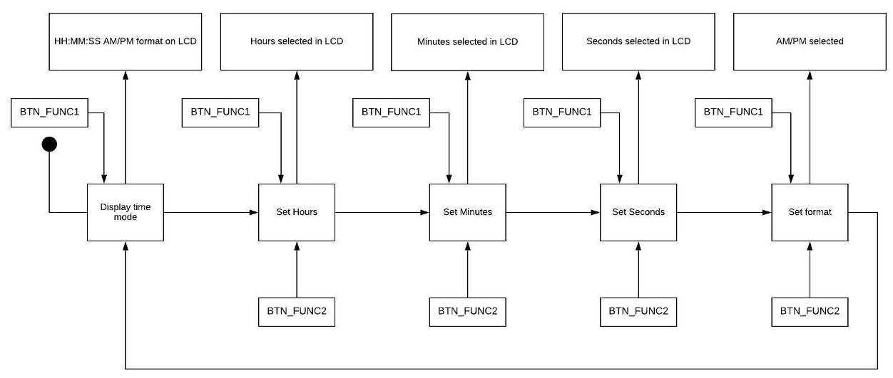

Figure .Display Time Mode

## 2.3-Alarm Mode

## 

Figure .Alarm Mode

## 2.3.1 case of Buzzer

Figure .Buzzer

## 2.4-Stopwatch Mode

## 

Figure .Stopwatch Mode

## 

# 3-API’s Component

|  |  |
| --- | --- |
| Req ID | Req_P03DGW_SRS_001_V05 |
| Req_P03DGW_SRS_002_V05 |
| Req_P03DGW_SRS_003_V05 |
| Description | This API is responsible of changing and Navigate between mode of Digital watch, 1st press the Display time mode, 2nd  press the Alarm mode, 3rd press the Stopwatch mode and 4th press back to Display Time mode and so on. |
| Name | DGW_error_tModeNavigation |
| Input Argument | u8 Loc_u8Mode_Switch u8 *Loc_u8ReturnCurntMode |
| Return Type | error_t |

|  |  |
| --- | --- |
| Req ID | Req_P03DGW_SRS_004_V05 |
| Req_P03DGW_SRS_005_V04 |
| Req_P03DGW_SRS_013_V04 |
| Description | This API is responsible of enter the Display Time Mode which inside calling LCD component to display Initialization format of clock and calling Adjust clock component at the beginning of the function and after adjusting the time show the current time. |
| Name | DisTimMd_error_tInitialization |
| Input Argument | u8* Loc_u8Returnvalue |
| Return Type | error_t |

|  |  |
| --- | --- |
| Req ID | Req_P03DGW_SRS_006_V05 |
| Req_P03DGW_SRS_007_V05 |
| Description | This API is responsible of read if the switch is pressed or not and assign the return value to pointer to integer. |
| Name | SW_error_tReadSwitchValue |
| Input Argument | u8 Loc_u8SwitchNo u8 *Loc_u8ReturnValue |
| Return Type | error_t |

|  |  |
| --- | --- |
| Req ID | Req_P03DGW_SRS_006_V05 |
| Req_P03DGW_SRS_012_V05 |
| Req_P03DGW_SRS_014_V05 |
| Req_P03DGW_SRS_021_V05 |
| Description | This API is responsible of select between field of the digital watch to be ready adjusted and if reached to format mode and Func1_sw is pressed the Digital watch save the last modification and exit the adjusting. |
| Name | DGW_error_tFieldSelect |
| Input Argument | u8 Loc_u8Func1Switch |
| Return Type | error_t |

|  |  |
| --- | --- |
| Req ID | Req_P03DGW_SRS_007_V05 |
| Req_P03DGW_SRS_008_V05 |
| Req_P03DGW_SRS_009_V05 |
| Req_P03DGW_SRS_010_V05 |
| Req_P03DGW_SRS_011_V05 |
| Req_P03DGW_SRS_015_V05 |
| Req_P03DGW_SRS_016_V05 |
| Req_P03DGW_SRS_017_V05 |
| Req_P03DGW_SRS_018_V05 |
| Req_P03DGW_SRS_019_V05 |
| Req_P03DGW_SRS_020_V05 |
| Description | This API is responsible of increment the value of which field is selected if a hours is selected doesn’t exceed more than 11 then reset to 0 and if minutes is selected doesn’t exceed more than 59 then reset to 0 and if format is selected toggle between AM and PM |
| Name | DGW _error_AdjustTime |
| Input Argument | u8 Loc_u8Func2Switch |
| Return Type | error_t |

|  |  |
| --- | --- |
| Req ID | Req_P03DGW_SRS_013_V04 |
| Description | This API is responsible of enter the Alarm Mode which inside calling LCD component to display Initialization format of clock and calling Adjust Alarm component. |
| Name | AlarmMode_error_tInitialization |
| Input Argument | u8* Loc_u8Returnvalue |
| Return Type | error_t |

|  |  |
| --- | --- |
| Req ID | Req_P03DGW_SRS_022_V05 |
| Req_P03DGW_SRS_007_V05 |
| Description | This API is responsible of compare between the current time and the value of alarm set (H=H && M=M && format==format ) |
| Name | Alarm_error_tAlarmCheck |
| Input Argument | u8 *Loc_u8ReturnValue |
| Return Type | error_t |

|  |  |
| --- | --- |
| Req ID | Req_P03DGW_SRS_023_V05 |
| Req_P03DGW_SRS_024_V04 |
| Description | This API is responsible of Enable Buzzer to ring |
| Name | Buzzer_error_tFireAlarm |
| Input Argument | Loc_u8State (Enable/Disable) u8 Loc_u8buzzerNo u8* Loc_u8RetrunValue |
| Return Type | error_t |

|  |  |
| --- | --- |
| Req ID | Req_P03DGW_SRS_025_V04 |
| Description | This API is responsible of enter the Stop watch which inside calling LCD component to display Initialization format of cloc and after reset the time show the current time. |
| Name | StopWatch_error_tInitialization |
| Input Argument | u8* Loc_u8Returnvalue |
| Return Type | error_t |

|  |  |
| --- | --- |
| Req ID | Req_P03DGW_SRS_026_V05 |
| Req_P03DGW_SRS_027_V01 |
| Req_P03DGW_SRS_028_V01 |
| Req_P03DGW_SRS_029_V01 |
| Req_P03DGW_SRS_030_V01 |
| Req_P03DGW_SRS_031_V01 |
| Req_P03DGW_SRS_032_V01 |
| Description | This API is responsible of starting the counting up of stop watch and reset after if user desire. |
| Name | StopWatch_error_tCountingUp |
| Input Argument | u8 Loc_u8Func1Switch(start) u8 Loc_u8Func2Switch(reset)  u8* Loc_u8Returnvalue |
| Return Type | error_t |

# 4-Layered Architecture

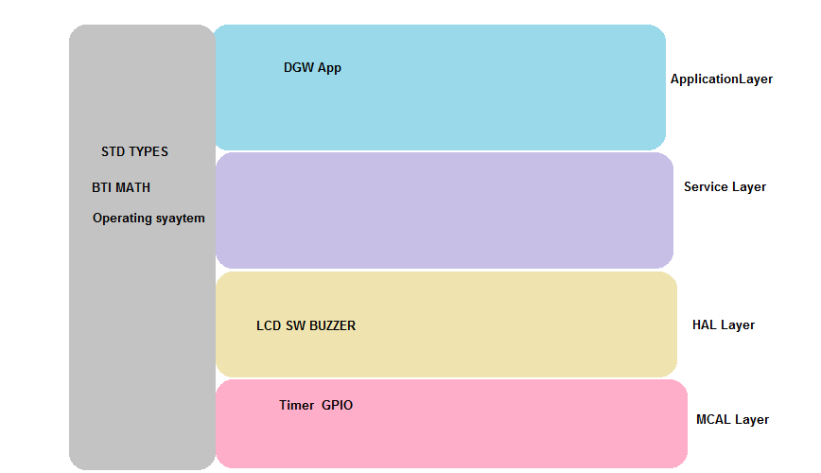

Figure .Layerd Architecture